
Improving your routine breast screening appointment
Welcome to our short survey for patients, carers and stakeholders. This survey is about your experiences of attending a routine breast screening appointment in the West Midlands.
Your feedback will help inform and support us to plan improvements to our NHS Breast Screening Programme.
It only takes around 7 minutes to complete the form, and your answers will be anonymous.
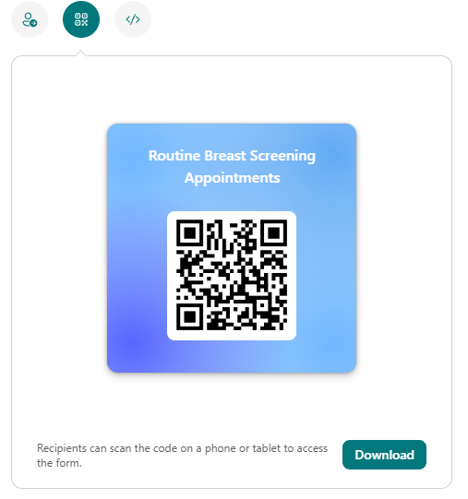
Please share your answers by 31 March 2025.
To complete the form online, please scan the QR code or visit https://forms.office.com/e/57Z0Pk5fUT
(Details of our Privacy Notice can be found here: www.england.nhs.uk/contact-us/privacy-notice/. It describes how we will use personal data, how you can contact us, and invoke your rights as a data subject. We will process your information in accordance with the requirements of the Data Protection Act 2018.)

1. Who are you completing the survey on behalf of?
If you are completing this survey on behalf of someone else, please answer the questions from their point of view.
- I am completing this survey about myself
- I am completing this survey on behalf of someone else (I’m a carer)
- I am completing this survey as a stakeholder
2. Which area of the West Midlands do you live in?
- Birmingham
- Solihull
- Black Country
- Coventry
- Warwickshire
- Herefordshire
- Worcestershire
- Shropshire
- Telford
- Wrekin
- Staffordshire
- Stoke on Trent
- Other: ______________________

3. When was the last time you attended a breast screening appointment?
- This is my first time, I have not attended an appointment before.
- One year ago
- More than two years ago
- I’m not sure

4. How easy was it to schedule your appointment?
- Very easy: The process was straightforward and quick.
- Easy: It was relatively simple, with only minor issues.
- Neutral: It was neither easy nor difficult.
- Difficult: There were some challenges, and it took longer than expected.
- Very difficult: The process was complicated and time-consuming.

5. How would you rate the communication and information provided before your appointment?
- Excellent: It was clear, timely, and comprehensive.
- Good: It was mostly helpful and clear.
- Average: It was adequate but could have been better.
- Poor: It was lacking or unclear.
- Very Poor: It was not useful.

6. How would you like to receive your invitation to your breast screening appointment?
In order of preference (1 most likely – 5 least likely)
- Letter
- Email
- Telephone call
- Test Message (SMS)
- NHS App

7. What would be your preferred appointment offer?
(please select all that apply)
- Early Morning (before 9am)
- Morning
- Afternoon (12pm+)
- Evening (5pm+)
- Weekday
- Saturday
- Sunday
- No preference.
8. How would you prefer to let us know if you needed to change or cancel your appointment?
- Telephone call to a member of staff
- Automated telephone service (leave a message)
- Text Message (SMS)
- Email
- Online booking system
- Other:_______________

9. Where would you prefer to go for your breast screening appointment?
Please select all that apply.
- NHS venue (Breast screening clinic, often within a hospital.)
- Community venue (e.g. village hall, sports centre)
- Mobile breast screening unit – this could be in lots of different locations, such as in a supermarket car park.
- Other, please specify

10. How long are you prepared to spend travelling to a breast screening appointment?
- Less than 15 minutes
- 15 - 30 minutes
- 30 - 60 minutes
- 1 hour +
11. Have you ever, or would you in the future, want to attend breast screening at a service other than your local one?
- Yes
- No
12. If yes… Could you provide further information on why this was your preference.
_________________________________________________________________________

13. How do you get to your Breast Screening Appointment?
- My own car or a friend/family member’s car.
- Public transport (bus, train, etc)
- Taxi
- Walk
- Other: ____________________

14. Were you informed about what to expect during and after the breast screening appointment?
- Yes, completely: I was fully informed about what to expect during and after the appointment.
- Yes, somewhat: I received some information, but it could have been more detailed.
- No, not really: I was given very little information about what to expect.
- No, not at all: I was not informed about what to expect during and after the appointment.

15. What motivated you to attend your breast screening appointment?
Please select all that apply.
- Routine check-up: It was part of my regular health check-up.
- Awareness campaigns: I was influenced by breast cancer awareness campaigns.
- Health concerns: I wanted to ensure there were no health issues
- Personal experience: I or someone close to me had a previous health scare.
- Other (such an employment support)

16. Overall, how would you rate your experience of the breast screening service?
(1 star =very poor, 5 stars =excellent)

17. What changes would you like to see in the breast screening service to improve your overall experience, or is there anything you would like to stay the same?
________________________________________________________________________

18. What do you think would encourage people you know to take up the offer of breast screening?

19. Which age category are you in?
- 50 – 70
- 71 or older
- Prefer not to say
20. How would you describe your gender?
- Female
- Male
- Non-binary
- Prefer not to say
- Other
21. How would you describe your ethnic origin?
- White – British
- White – Irish
- Mixed - White and Black Caribbean
- Mixed - White and Black African
- Mixed - White and Asian
- Asian or Asian British – Indian
- Asian or Asian British – Pakistani
- Asian or Asian British – Bangladeshi
- Black or Black British – Caribbean
- Black or Black British – African
- Other
- Prefer not to say
22. Do you consider yourself to have a disability?
- Yes
- No
- Prefer not to say

Thank you for your time.
Macmillan Cancer Support has a free helpline that's open every day from 8am to 8pm.
They're there to listen if you have anything you want to talk about.
Call: 0808 808 00 00
If you have completed a paper version of this questionnaire, please return to the team who gave it to you so that your feedback can be included.
england.midlandsengagement@nhs.net

