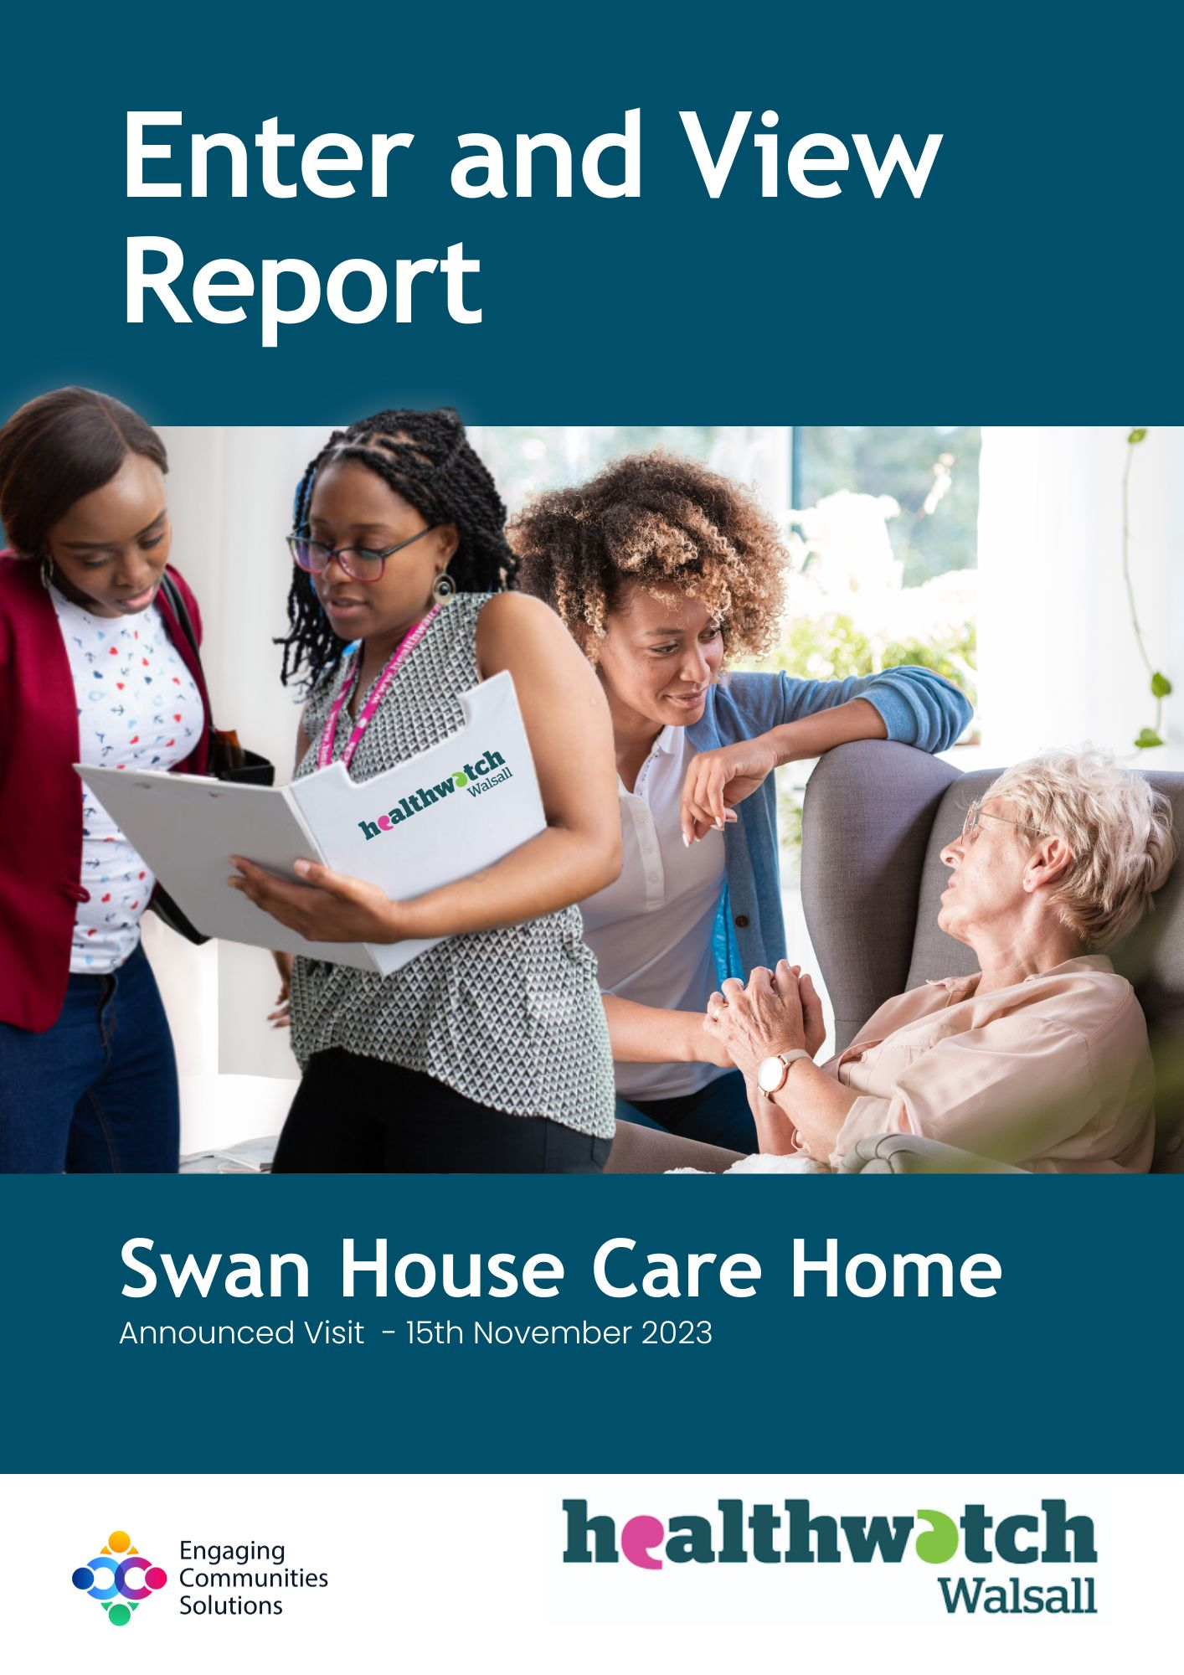

Enter and View Report
Swan House Care Home
Announced Visit -15th November 2023
Healthwatch Walsall – managed by Engaging Communities Solutions

What is Enter and View
Part of Healthwatch Walsall remit is to carry out Enter and View visits. Healthwatch Walsall Authorised Representatives carry out these visits to health and social care premises to find out how they are being run and make recommendations where there are areas for improvement.

The Health and Social Care Act allows Authorised Representatives to observe service delivery and talk to service users, their families, and carers on premises such as hospitals, residential homes, GP practices, dental surgeries, optometrists, and pharmacies.

Enter and View visits can happen if people tell us there is a problem with a service but, equally, they can occur when services have a good reputation so that we can learn about and share examples of what they do well from the perspective of people who experience the service first-hand.

Healthwatch Walsall Enter and View visits are not intended to specifically identify safeguarding issues. However, if safeguarding concerns arise during a visit, they are reported in accordance with Healthwatch Walsall Safeguarding Policy, the service manager will be informed, and the visit will end. The Local Authority Safeguarding Team will also be informed.

Contents:
Page
Provider details 3 - 4
Acknowledgments 4
Disclaimer 4
Authorised Representatives 4
Who we share the report with 4
Healthwatch Walsall details 4
Healthwatch principles 5
Purpose of the visit 5
What we did 5
Environment findings 6
Resident interviews 7 -8
Relative Interviews 9 - 10
Staff interview 10 - 11
Manager interview 11 - 12
Findings 12
Recommendations 13
Provider feedback 13
Provider details
Name and Address of Service: Swan House Care Home
Pooles Lane, Short Heath, Willenhall
Postcode: WV12 5HJ
Telephone: 01922 407040
Specialisms /services:

- Accommodation for persons who require nursing or personal care
- Treatment of disease, disorder or injury
- Caring for adults over 65 yrs.
- Caring for adults under 65 yrs.
- Dementia
- Mental health conditions
- Physical disabilities
- Sensory impairments

Resident capacity is forty five, a mix of twenty two residential and twenty three nursing care residents. There are currently 40 residents at the home.

We were informed that there are a number of new permanent staff that have recently joined currently shadowing existing staff. The home uses agency staff as needed.

Swan House is run by: Absolute Healthcare Swan House Limited
Current CQC report status: Requires Improvement across all five categories
Latest inspection: 30 August 2023
Report published: 11 November 2023
Link to CQC report: https://www.cqc.org.uk/location/1-12628094249

Acknowledgments
Healthwatch Walsall would like to thank the Home Manager, owners, and care staff and all the residents and relatives for their co-operation during our visit.

Disclaimer
Please note that this report is related to findings and observations made during our visit made on 15th November 2023. The report does not claim to represent the views of all service users, only those who contributed during the visit.

Authorised Representatives
Lynne Fenton – Senior Insight Advocate Lead, Healthwatch Walsall
Tom Collins – Engagement & Information Lead, Healthwatch Walsall
Peter Allen – Community Outreach Lead, Healthwatch Walsall

Who we share the report with
This report and its findings will be shared with the provider, Local Authority Quality Team (depending on the visit), Black Country Integrated Care Board (BICB), Care Quality Commission (CQC) and Healthwatch England. The report will also be published on the Healthwatch Walsall website. Link: https://tinyurl.com/3tuhmdrx

Healthwatch Walsall Contact Details
Address: Blakenall Village Centre, 79 Thames Road, Blakenall, Walsall WS3 1LZ
Website: www.healthwatchwalsall.co.uk
Freephone: 0800 470 1660
Social media: Facebook - https://www.facebook.com/HealthwatchWSL
Instagram - https://www.instagram.com/healthwatchwsl/
Twitter - https://twitter.com/HWWalsall

Healthwatch Principles
Healthwatch Walsall’s Enter and View programme is linked to the eight principles of Healthwatch, and questions are asked around each one.

- A healthy environment: Right to live in an environment that promotes positive health and wellbeing.

- Essential Services: Right to a set of preventative, treatment and care services provided to a high standard to prevent patients reaching crisis.

- Access: Right to access services on an equal basis with others without fear of discrimination or harassment, when I need them in a way that works for me and my family.

- Receive safe, dignified and quality services: Right to high quality, safe, confidential services that treat me with dignity, compassion, and respect.

- Information and education: Right to clear and accurate information that I can use to make decisions about health and care treatment. I want the right to education about how to take care of myself and about what I am entitled to in the health and social care system.

- Choice: Right to choose from a range of high-quality services, products and providers within health and social care.

- Being listened to: Right to have my concerns and views listened to and acted upon. I want the right to be supported in taking action if I am not satisfied with the service I have received.

- Being involved: To be treated as an equal partner in determining my own health and wellbeing. I want the right to be involved in decisions that affect my life and those affecting services in my local community.

Purpose of the visit
As part of our Enter and View schedule we primarily select care/nursing homes that are rated as ‘Requires Improvement’ or ‘Inadequate’. However, on occasions we visit venues that hold a good or ‘Good’ or ‘Outstanding’ rating to understand/compare the levels of service delivered in care and seek to identify good practice that may be shared.

What we did
Authorised Representatives looked around the external area of the property (details below). On entering the building, Authorised Representatives were greeted by a member of the team who asked the Authorised Representatives to sign in and sanitise their hands. This was followed by a short discussion with the Manager about the visit.

Environment findings
External
The exterior of the property is maintained with a private car park for up to 15 cars. The main entrance was via a secured door. Request to enter was by use of a doorbell. A security keypad was in place to enter.
To the front of the property there are no steps so access is easy for wheelchair access to the entrance of the building.
There is external lighting and CCTV in place.
There is a garden area to the rear/side of the property with access points from the main building. We observed a resident enjoying the outside space on our visit. This resident was dressed appropriately to meet the conditions outside, they also had a hot drink.
Internal
We asked for a brief tour of the communal areas and were shown two communal lounges and two dining areas on the ground and first floor. At the moment residential care is delivered on the ground floor with nursing/dementia care being delivered on the upper/first floor.
Décor was monotoned, shades of light and mid grey defining the upper and lowers walls and handrails. Toilets and fire exits were clearly marked. There were no obstructions in the hallway. There is also an internal lift.

Some building work was being carried out but the area was secure and not accessible to unauthorised personnel. There were several slip hazard signs easily seen whilst cleaning was being undertaken.

The setting appeared to be clean and tidy in the areas we visited. There were small kitchenettes in the lounge and dining areas we visited allowing for the making of drinks and washing up. Some were closed but were not locked.

During our visit to the first-floor dining area we noted that there was a notice board that had Monday’s menu, the day of our visit was Wednesday so the board had not been updated. There were menu cards on the table for Tuesday so those too had not been updated

They also reflected a three-course meal (lunch?) but there was only one item of food per course, therefore appearing that there was a lack of food choice.

The main course was defined as ‘Chefs Special’ without any definition of what it was.
We noted that there are nursing stations on each level and on the first floor there was a hair salon room. When we exited the lift on the first floor there was an odour present.

Resident Interviews
We spoke to three residents on the visit. There was a small number of residents in the two lounge areas at the time of our visit.

We asked what was life like for them in their home?
One resident shared more than the other residents we were able to engage with. It was noted that they have varying levels of dementia. They indicated that they sometimes have breakfast in bed or sometimes in their chair if they choose. They can sit in their chair until lunchtime, reading, watching TV and if they are offered activities that they can take part in.
“I enjoy living here”
“Get up with staff support”
“It’s alright”

We asked what choices they have?
“Choice of my own, how I dress, activities, I don’t choose time of bed”
“Food OK, staff help me with everything”
“Not sure”

We asked how safe they felt at the home?
“Yes I do, one or two residents are a bit sharp with me. I have an alarm in my bedroom”
“Can use bell and staff come quickly”
“People are kind and caring. Agency staff don’t know your needs. No pull chord, safe-ish”

We asked how long they had been in their home and if they are involved in their care?
“I have been here over three years, I have say in my care. I have been in several homes”
“Not long. I look after myself, staff help sometimes”
“Not sure”

We asked if they felt cared for?
“Yes”
“I see my Doctor if needed. Optician and hairdresser”
“I can see a Doctor, Optician. Make my own appointments, treated well-ish, depending on carer”

We asked if they had an issue do they know who to speak to?
“I find it hard at times to make a sentence but I would try”
“I would speak to staff, yes”
“Yes”

We asked if they had an issue can they raise a concern without repercussions?
“I would speak to staff, yes”
“I could raise a concern; my GP visits me here”
“Tell Someone”

We asked if they have a balanced healthy diet, with drinks and activities?
“I try to have a balanced diet. Plenty of food and drink. I’m told what’s available and then they say it’s gone now”
“Yes”
“Yes it’s OK”

We asked how involved in their home they are?
“No resident meetings here”
“Not sure”

One resident did not wish to take part further.

We asked if they could change one thing what would it be and why?
“Happy here”
“Want supervision for the home by the council”

Relative Interviews
We spoke to three visiting relatives during the visit.
This was in the upper part of the building where nursing care is given.

We asked what was life like for their relative in the their home?
“New staff, agency staff. But feel know relative enough”
“24 hours support. A lot better and so what they need”
“Cramped space for visitors, feel on Friday, Saturday, Sunday not enough staff. Difficult to communicate with some staff as English is poor”

We asked what choices do the residents have?
“Asked daily, about choices, feel has choice and is listened to. Enough staff around”
“Not sure. No food choice, limited menu, resident needs gluten free, could be more choice”
“Resident is asked daily about choices, and is listened to, feel enough staff around”

We asked how safe they felt their loved one is at the home?
“Safe. There are also various crash mats in place. They feel safe”
“Happy with safety here”
“Alright. Not seen alarm bell unsure if there or if work”

We asked how long they had been in their home and if they are involved in their care?
The residents had been in the home a range of time from one week to a year.

We asked if they felt cared for?
“Yes, feels empathy”
“No issues. Need to communicate with on a regular basis”
“Yes”

We asked if they had an issue do they know who to speak to?
“Talk to staff initially, then speak to Manager”
“Go to Manager and we are encouraged to speak to them, we get calls from the home Manager with updates”
“Yes, feel confident”

We asked if they had an issue can they raise a concern without repercussions?
“When my relatve first came, I had several things to say but discussed them and all was explained and resolved”
“Yes very comfortable”
“Raised issue of limited car parking spaces”

We asked the relative if there is a balanced healthy diet, with drinks and activities?
“Yes. Good. Brings tea around. Gets invoved with activities including singing”
“Yes, able to communicate and ask”
“Gluten free issue”

We asked how involved are they in the care of the resident?
“Yes, most days have a chat with staff. Also get calls about the resident”
“No meetings”
“Pop in now and again, resident calls every day”

We asked if they could change one thing what would it be and why?
“Staffing levels at weekend. Not sure if meeting resident’s needs. Sometimes not sure if you are speaking to agency staff or permanent staff”
“Try to retain staff so they are familiar to residents and relatives”

Staff interview
We spoke to a care staff member who delivers the activities programme at the home.

We asked what the care planning and risk assessment process was that they work to? They said that residents initial care needs are identified when an assessment is carried out with the resident/relative(s). Activities are regularly shared with residents.

When asked how much time they had to spend with residents? We were told that they spend as much time as they can with each resident as it is a person-centred approach interacting with them.

We asked about staff training, the delivery and regularity. We were told that it is a mix of online training and some inhouse/practical training.

We asked how they dealt with resident concerns/issues? They answered “escalate to Manager” record issue.

When asked about the supervision and support the staff member received, they mentioned that they receive regular supervisory sessions.

The staff member said that they felt very confident in raising any concerns with Management/Owners.

When asked if they could change one thing what would it be? They replied, “area for activities, a dedicated space.” The visitor pod which was used for relative visits during COVID19 was now a storage area.

The Activities co-ordinator gave us access to an activities file which was kept in a calendar, monthly order. This showed photographs and documents of an extensive range of events such as: Halloween, Wizard Of Oz day, outside summer barbecues, music therapy, stage shows put on by the staff, life skills workshops, birthday parties, art therapy, fitness exercises, bingo, pamper days, resident meetings, sensory workshops, and spiritual events/visits by clergy.

We informed that there are quarterly resident meetings. The staff member seek to engage with residents all the time, non-stop.

When asked what are your current challenges? We were again told “space for activities and undertaking trips for residents as there is no transport”.

Management interview
Nearing the end of the visit we usually undertake a Managers interview. But the Manager was engaged with relatives so we spoke with the Deputy Manager.

We asked if they felt confident in their role. They answered “Yes” they had worked at the home some time ago and had held a Manager position elsewhere, also a role as a Nurse.

We asked them to describe the care planning and risk assessment process? We were told that a prospective resident pre-assessment made using various information points such as social worker reports, hospital discharge records, a face-to-face assessment
can be made or over the telephone with workers. Once accepted there is a seventy two hour period to compete all the resident initial records.

A checklist of resident needs is identified and recorded. This information is currently kept electronically.

We asked how much time they are able to spend with residents? They informed us: mornings, breakfast, and lunchtime they can support staff. The Home Manager spends time with the residents and spot checks records.

They have protected time for training which is updated as and when required covering mandatory training and any additional new training areas.

We asked how they deal with comments or concerns from residents/relatives? We were informed that there is a complaints policy/procedure. But initially it may be verbal and could be resolved at that stage. Otherwise the procedure would be followed.

We asked if there were any resident/relative meetings taking place. We were told “no but there is a plan to resume them”.

The Deputy Manager held NVQ level five and is a Nurse. Training is a mix of online and external face to face training.

We were also informed that the staff spend one to one time with each resident each day for a period of fifteen minutes. This takes place each day with staff sharing this protected time with different residents.

We asked if they could change one thing what would it be and why? They said they currently use two care planning systems and that one was better than the other. They would prefer to use the one system.

Findings
- We noted that there was only one meal choice on a menu card left out on the tables for a different day to that of our visit.
- The resident menu blackboard on the upper level had an old menu displayed.
- When going to the upper level there was an odour that was noted, this later dissipated.
- The internal décor was very monotone, shades of grey and appeared tired.
- Staff were in the corridors and in the lounge areas with residents attending to needs and serving drinks.
- Drinks were consistently offered to the residents we saw.
- A relative felt that there was not enough staff at weekends and communication with new staff was difficult
- There appeared to be a number of activities happening for residents.

Recommendations
- Check daily menus choice is more than one option and displayed correctly
- Introduce and maintain resident/relative meetings for service delivery feedback purposes and record findings
- Refresh décor around the home
- Consider a dedicated activities area if not already identified
- Identify any opportunities for external visits/activities
- Re-visit resident changing dietary requirements to meet any changing needs

Provider feedback
We asked the provider of services at Swan House for comments on the above report and we received the following:

“We appreciate your feedback as we are always striving to improve our service by providing exceptional standards of personalised care and promoting a good quality of life for all Service users living at Swan House.

Thank you for your recommendations, and I would like to assure you that we will be implementing the necessary actions as outlined in your report to drive improvement within our service and look forward to welcoming you again in the future”.

Healthwatch Walsall
How to contact us
Offices: Blakenall Village Centre
79 Thames Road
Blakenall
Walsall
WS3 1LZ
Tel: 0800 470 1660
Email: info@healthwatchwalsall.co.uk

